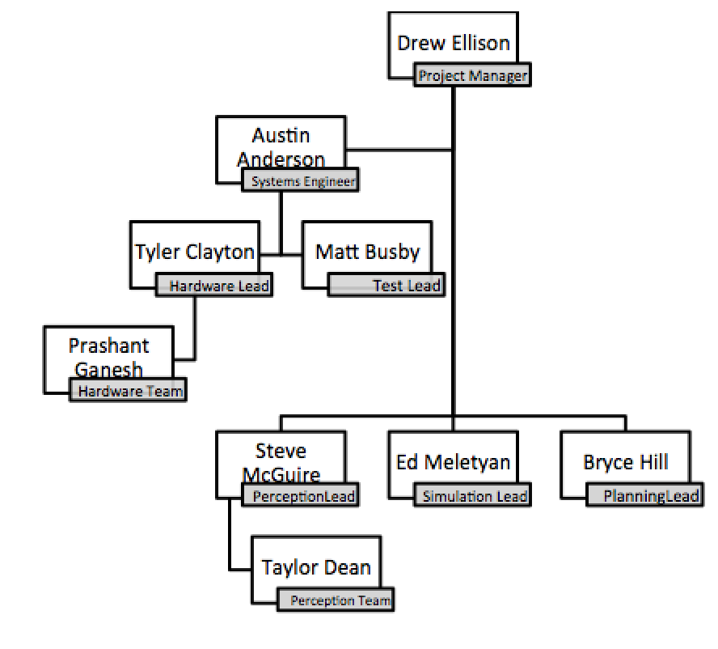**Project Overview:**

**Team Organization:**

Figure : Organizational Chart

The team is organized according to the chart displayed in Figure 1. Five main subsystems were chosen with the following responsibilities:

1. **Hardware:** Design and construction of vehicle sensor mounts, power distribution systems, wireless connections, and safety piloting (Members: Tyler Clayton and Prashant Ganesh)
2. **Perception:** Development of algorithms for localizing and mapping within a building and for identifying humans within that building. Responsible for providing reliable pose estimates for use in controllers and target identification and localization. (Members: Steve McGuire and Taylor Dean)
3. **Flight Control:** Development of interfaces between pose estimators, vehicle autopilots, and waypoint generators. Responsible for providing reliable flight given a reliable pose estimate. (Members: Austin Anderson and Drew Ellison, not reflected above)
4. **Planning:** Responsible for providing a list of waypoint goal positions in a building map to provide to the flight control subsystem. (Members: Bryce Hill and Ed Meletyan)
5. **Simulation:** Development of a reliable simulation environment to model controller and path planning performance in the presence of uncertain position estimates.

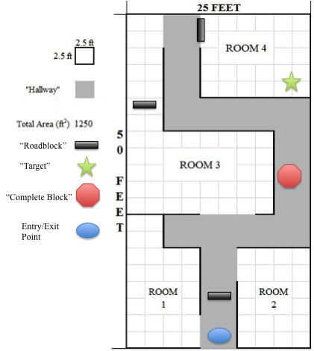**Concept of Operations:**

Figure : Example of expected exploration space

The goal of this project is to develop an aerial system that can navigate through a building with incomplete information about the environment. Specifically, a system will be provided with a building blueprint (positions of walls and doors), and will autonomously plan a trajectory, navigate through the building, and identify any humans found within the building. The system will not have any knowledge of the location of humans in the building, or on any obstacles not shown in the blueprint. While the system is performing this task, it will update its map with locations of previously unknown obstacles and mark the locations of humans on this map. Additionally, the system will have the ability to tag, or confirm, targets after it has identified a target as a human. The system will the exit the space after performing a search for humans, and report these results to a user located at the building entrance point.

**Design Overview:**

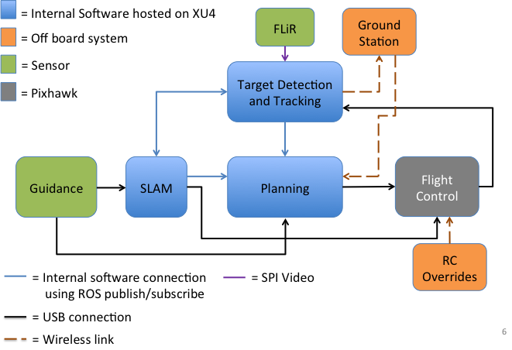

Figure : High Level Design

The high level design of the system is shown in Figure 3. The system consists of two main sensor systems, the FLiR Lepton for thermal imaging and identification of human targets, and the DJI Guidance system, which will provide stereoscopic grayscale images, an onboard visual odometry solution, and distance to nearest obstacles in five directions.

There are then three primary software blocks: Target ID, SLAM, and Planning.

Target ID algorithms will process imagery from the FLiR sensor to produce pose estimates on the map for any humans that are identified.

SLAM, or simultaneous localization and mapping, is run through a ROS package called RTAB Map. This will be fed stereo images and visual odometry from the DJI Guidance sensor system in order to produce a visual pose estimate, and a 3D map of the explored space.

The planning block will calculate a list of waypoints based on exploration criteria in order to effectively search the space for human targets. This block will take the current position, and a list of received tracks from the target ID subsystem, which will allow it to identify if a replan should occur in order to localize and confirm targets.

The Robot Operating System (ROS) will be used for communication between different software systems on each vehicle, for communication between vehicles, and for communication between vehicles and a ground station.

At the ground station, a user has the ability SSH into any ODROID flight computer onboard each vehicle in order to debug software subsystems. Additionally, ROS allows users to listen to data topics being published, allowing an extensive user debug interface.   
  
End users of the system will communicate with the system using a ROS interface which allows the user to upload building blueprints, read flight diagnostics, and receive human target locations in an updated SLAM map.

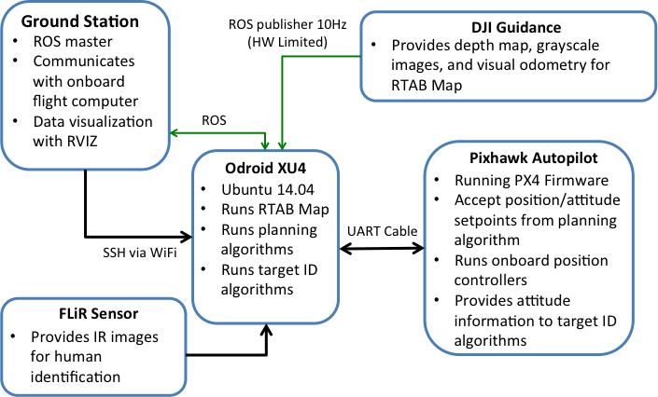

**User Interface Diagram:**

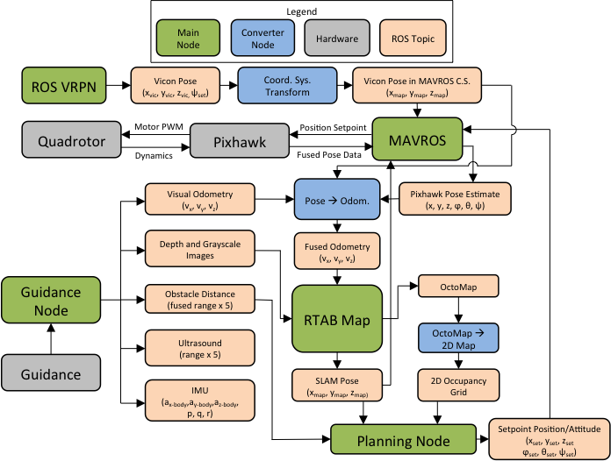

**Vehicle Block Diagram:**

The diagram above displays the full vehicle system (with the exception of target identification) for vehicle pose estimation, waypoint planning, and autonomous flight controls. These nodes will be further described in the following subsections.

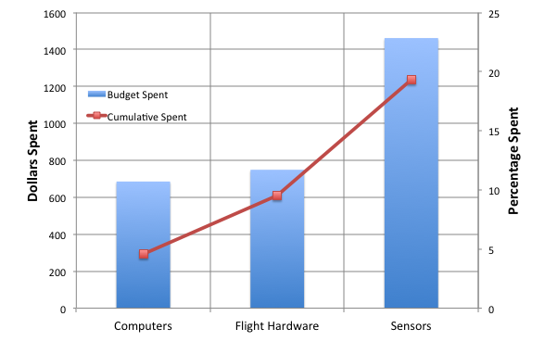**Budget:**

Figure : Budget Summary

The budget is broken down into three categories: computers, flight hardware, and sensors as shown in Figure 4. The itemized breakdown of hardware can be found below. The bar chart percentages are based on a $15,000.00 budget.

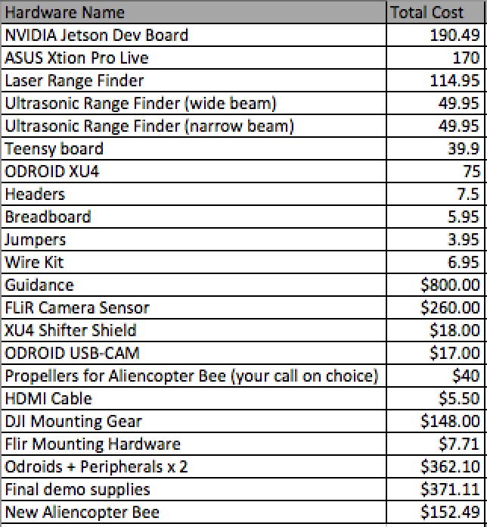

**Schedule:**

The proposed schedule for next semester has not yet been finalized. During the next semester, the team predicts it will be able to accomplish the following tasks:

1. Waypoint following in VICON
2. SLAM localization with RTAB Map
3. Reliable target identification using FLiR
4. Closed loop planning block and waypoint following on quad
5. Waypoint following closed loop with SLAM running open loop Target ID
6. Reporting of updated 2D maps from SLAM algorithms post flight

Specifically, the following tasks will not be met by the end of next semester by current predictions due to man-hour and time constraints:

1. Multi vehicle flying
2. Target confirmation/tagging
3. Package delivery
4. Multiple vehicle coordination with ground robots
5. Fast/agile flight speeds ( > 2m/s)